ATTENTION WHISPERING WATERS RESIDENTS:
On Tuesday, June 22nd, starting at 9 AM, Duke Energy will be replacing the transformer on the north side of the property. This will impact electrical service to parts of the WW campus.
The replacement will take a minimum of 5 hours, and possibly up to 8 hours to complete.
During that time buildings 1, 2, 7, 8, and the north garage along 11th street will NOT have power:
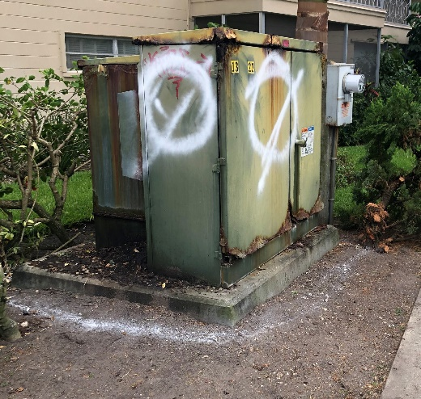
Please be aware, and make plans accordingly:
- If you are in one of the four buildings impacted, lower your AC settings well in advance to keep them cool.
- Water will not be impacted and will continue to be available to you.
- Charge your electronic devices to full capacity.
- If you have a car in the north garage move it in advance if you will have need for it during the day. Without power, the garage door openers will not function.
- Keep in mind elevators in these four buildings will also not function.
- Unplug your high value electronics or protect them with surge protectors for when the power comes back on.
There are no plans to replace the south side transformer currently. The north unit is leaking oil which is generating the need for the replacement. Any other questions please contact your governor.

